**Day 1 Lab Assignments**

1. Create “contact us” page using new HTML 5 input elements and attributes.
2. Create new “home” page for your personal website using HTML5 structural elements, and use this layout.

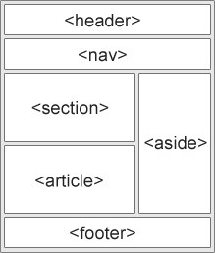

1. Try new semantic elements (Time, Meter,Mark,progress).
2. Make a star rating control as an empty star image (provided in the lab files), and changes as following:
   1. When mouse over it, it converts to filled star (like rating stars control, but you can try it on one star only in the beginning, then change it to 5 stars).
   2. When mouse move away from it, it changes back to empty star.
   3. When mouse over it, and it clicked, make it fixed on the filled star (don’t changes again when mouse move away from it, and **use data-* attributes to save the status of clicked image).**
   4. When re-clicked again (after it was fixed from first click), it backs to empty star when mouse is out.

stars

1. Try to use Video and audio

**Bonus Assignments:**

1. Make a page (and use MicroData ont it) that contains your university (use CollegeOrUniversity schema), and write your data as one of the graduates of this university (use [alumni](http://schema.org/alumni) property and nested person schema).
2. Search for HTML5 new tags and use it, and use it.
3. Search for CSS3 new features and use it.

**<Thank>YOU </Thank>**